Imbalanced Maritime Incident Classification Using BERT–BiLSTM with Attention and LLM-Based Data Augmentation
Mohammad Mahdi Arab  Faculty of Computer Engineering  Shahrood University of Technology  Shahrood, Iran  math.mohammad.arab@shahroodut.ac.ir | Hoda Mashayekhi*  Faculty of Computer Engineering  Shahrood University of Technology  Shahrood, Iran  hmashayekhi@shahroodut.ac.ir | Maryam Khodabakhsh  Faculty of Computer Engineering  Shahrood University of Technology  Shahrood, Iran  m_khodabakhsh@shahroodut.ac.ir
*Corresponding author: Hoda Mashayekhi (e-mail: hmashayekhi@shahroodut.ac.ir).
Abstract—With the growing number of incident reports collected by maritime investigation bodies, their automatic classification is becoming increasingly important for maritime safety management. However, this classification is still largely manual, and the most safety-critical incident types, such as fire, flooding and capsizing, are also the rarest, so models optimized for overall accuracy can largely overlook them. To address this limitation, we propose a framework that combines a fine-tuned Bidirectional Encoder Representations from Transformers (BERT) encoder, which represents the maritime vocabulary in context, a Bidirectional Long Short-Term Memory (BiLSTM) network, which follows the sequence of events in a report, and an attention layer, which highlights the most informative words. An imbalance-handling module protects the rare classes with class-weighted losses, oversampling and data augmentation by a Large Language Model (LLM) with a label-consistency filter. On 5,762 public reports of the UK Marine Accident Investigation Branch (MAIB) in nine classes, the framework significantly outperforms a Term Frequency–Inverse Document Frequency (TF-IDF) and Support Vector Machine (SVM) baseline and, on average, exceeds the BERT–BiLSTM model of recent work in macro-F1 and in the recall of safety-critical classes. Furthermore, the attention analysis reveals recurring hidden issues within broad incident classes, supporting faster and more proactive maritime safety management.
Keywords—Maritime Safety, Marine Incident Reports, Text Classification, BERT, BiLSTM, Class Imbalance, Data Augmentation, Large Language Model

I. Introduction
Marine accidents such as collisions, groundings, fires, flooding and capsizing cause loss of life, damage to vessels and pollution [1]. Investigation bodies such as the UK Marine Accident Investigation Branch (MAIB) record every reported accident and incident as a short narrative with its type. These narratives show which incident types are frequent and call for new regulations [2], but they are still coded manually by experts, which is slow and depends on the coder.
Automatic classification of incident reports faces three challenges. First, the classes are highly imbalanced: accidents to persons outnumber capsizing incidents by a factor of about 17 [3], and the most safety-critical types, fire, flooding and capsizing, are among the rarest, so a model that maximizes accuracy can largely ignore them [4]. Second, each report carries a single label although many incidents are a chain of events, such as an engine failure that leads to a grounding [1]. Third, the reports use a specialized maritime vocabulary that general-purpose language models rarely see [2].
Pre-trained Transformer encoders such as Bidirectional Encoder Representations from Transformers (BERT) [5] have recently been applied to maritime accident texts [1], [2], [6], [7]. In particular, Zhao et al. [1] combined BERT with a Bidirectional Long Short-Term Memory (BiLSTM) network and reached an accuracy of 89.8% in classifying accident causes. The main problem, however, remains open: accuracy is dominated by the frequent classes, and the recognition of the rare, safety-critical incident types still leaves room for improvement, which matters given the sensitivity of the task: a missed fire or flooding report costs more than a missed minor injury. It is aggravated by the limited number of labeled reports: a few dozen examples per rare class (69 Capsizing reports in our training set) are hardly enough to learn their wording.
This study addresses this problem with a framework built for incident reports. The contributions are: (1) a BERT–BiLSTM–attention framework whose components address the vocabulary, the event sequence and the position of decisive words in a report, extending the BERT–BiLSTM model of [1] with attention pooling; (2) an imbalance-handling module that combines class-weighted losses, oversampling and data augmentation by a Large Language Model (LLM) with a label-consistency filter, which writes new training reports for the rare classes; and (3) an attention and error analysis that reveals recurring hidden issues within broad classes and shows that the remaining errors lie mostly between cause and consequence classes. The framework is evaluated on 5,762 public MAIB reports with repeated runs, a classical baseline and significance tests. Section II reviews related work, Section III introduces the framework, Section IV presents the evaluation and discussion, and Section V concludes.

II. Related Work

A. Text Analysis of Maritime Accident Reports
Zhao et al. [1] classified accident causes, single sentences extracted from reports, into 32 categories and mined the predicted causes of 1,337 accidents on China’s coasts with Apriori association rules. They compared BERT, BERT with a pooling head and BERT + BiLSTM, with accuracies of 88.7%, 88.3% and 89.8% (macro-F1 0.887, 0.883 and 0.897). The three models, however, used different dropout, regularization, gradient-clipping and activation settings, each was trained once, and, as described, the classes were balanced by synonym replacement, back-translation and AI-generated text before the data were split into training and test sets; the data are not public. Black et al. [2] classified human factors in maritime accident reports according to the SHIELD taxonomy with a domain-adapted BERT model. Yu et al. [6] and Wang et al. [7] extracted knowledge from collision and fire reports with BERT and XLM-RoBERTa followed by a BiLSTM–Conditional Random Field (CRF) tagger. A BiLSTM on top of a Transformer encoder is thus a recurring design in this domain, because accident narratives are chains of events whose order matters; our framework builds on this design and evaluates it under identical settings. LLMs have also entered the maritime domain [8], [9], but, to our knowledge, LLM-generated accident reports have not been checked for label consistency or kept out of the test data.

B. Class Imbalance and Data Augmentation
Loss-level methods give rare classes more weight: inverse-frequency weighting, the focal loss [10], which down-weights confidently classified examples, and the class-balanced loss based on the effective number of samples [4]. Data-level methods change the training set: random oversampling repeats reports of small classes, the Synthetic Minority Over-sampling Technique (SMOTE) [11] interpolates between examples, which does not suit text, and text augmentation ranges from synonym replacement and back-translation to LLM generation filtered by a classifier [12]. This study differs from previous work in extending the architecture of [1] with attention and an imbalance-handling module whose LLM paraphrases pass a label-consistency filter and enter the training set only, in comparing loss-level and data-level treatments on the same data and protocol, and in evaluating with macro-F1, the recall of safety-critical classes and significance tests rather than accuracy alone.

III. Methodology

A. Framework
In the proposed framework (Fig. 1), each component answers a challenge of incident reports: BERT encodes the specialized vocabulary in context, a BiLSTM follows the chain of events, an attention layer pools the BiLSTM states so that decisive words count wherever they appear, and a linear layer with softmax predicts one of the nine incident types. The imbalance-handling module protects the rare classes through the training data (Section III-F) and the loss (Section III-E), whose gradient fine-tunes all layers.
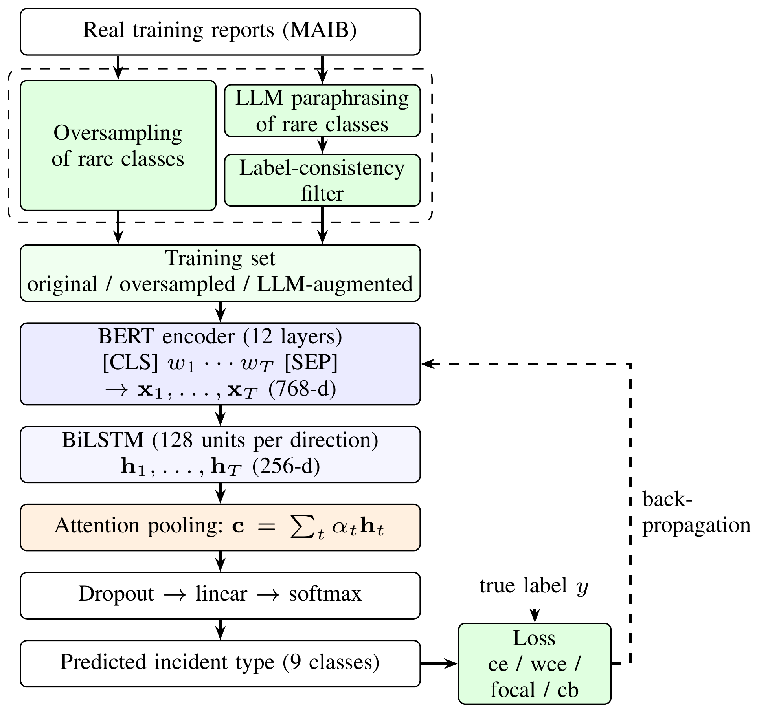
Fig. 1. The proposed framework. Green: the imbalance-handling module, which builds the training set (dashed: oversampling, or LLM paraphrasing of rare-class reports checked by a TF-IDF + SVM label-consistency filter) and offers losses that favor rare classes. The loss compares the prediction with the true label, and its gradient fine-tunes all layers.

B. BERT Encoder
The meaning of maritime terms depends on the context; fire, for example, can describe the incident or a fire drill. We therefore use BERT-base (uncased) [5], a 12-layer Transformer pre-trained on general English text, which represents every word in the context of the whole report. A report is split into word-pieces $w_{1},…,w_{T}$ framed by the special tokens [CLS] and [SEP], and BERT turns each token into a 768-dimensional vector,
$$=BERT\left(w_{1},…,w_{T}\right).$$ | (1)
Through self-attention, each vector $x_{t}$ depends on the whole report, so the same word receives different vectors in different contexts. All BERT weights are fine-tuned on our task.

C. BiLSTM Layer
An incident report narrates a chain of events, and the type depends on how it ends: an engine failure that ends with a tow to port and one that ends on the rocks start alike but are typically recorded as Loss of Control and Grounding. A recurrent layer reads the report step by step and carries a memory of the events read so far. Following Zhao et al. [1], who found this combination effective for accident reports, the token vectors are therefore fed into a BiLSTM [13], [14] with 128 units per direction:
$$\begin{matrix}{\vec{h}}_{t} & ={LSTM}_{f}\left(x_{t},{\vec{h}}_{t−1}\right), \\ {\overset{⃖}{h}}_{t} & ={LSTM}_{b}\left(x_{t},{\overset{⃖}{h}}_{t+1}\right), \\ h_{t} & =\left[{\vec{h}}_{t};{\overset{⃖}{h}}_{t}\right].\end{matrix}$$ | (2)
The forward LSTM reads the report from left to right and the backward LSTM from right to left, each keeping a memory of the tokens read so far through its gates. Their concatenation $h_{t}$ (256 dimensions) summarizes the events on both sides of token $t$, linking, e.g., an early failure to its later consequence. Padding is skipped, so each direction stops at the true end of the report.

D. Attention Layer
The words that decide the incident type, such as grounded or smoke, often appear in the middle of a report, where the final BiLSTM states may have partly forgotten them. Moreover, safety analysts need to see why a report was assigned to a class before they rely on it. The proposed framework therefore pools all states with additive attention [15]:
et=v⊤tanhWht+b, αt=expetk​expek,c=t​αtht. | (3)
The score $e_{t}$ measures how useful token $t$ is; $W$, $b$ and $v$ are trainable, with a 128-unit scoring layer. The softmax turns the scores into weights $α_{t}$ that are positive and sum to one (padding receives zero weight), and the report vector $c$ is the weighted average of the states, so informative words count more wherever they appear. The weights are stored to inspect which words the model relied on (Section IV-F).

E. Classification Layer and Loss Functions
The pooled vector passes through dropout (rate 0.1) and a linear layer with softmax,
$$\hat{p}=softmax\left(W_{o} dropout\left(c\right)+b_{o}\right),$$ | (4)
which gives the probability of each of the $K=9$ classes; the most probable class is the prediction. For a batch of $B$ reports, let $p_{i}$ be the predicted probability of the true class $y_{i}$ of report $i$, $N$ the number of training reports and $n_{c}$ the number of training reports of class $c$. We compare four losses.
Cross-entropy (ce) treats all reports equally, so the large classes dominate it:
$$L_{ce}=−\frac{1}{B}\sum_{i=1}^{B}{log}p_{i}.$$ | (5)
Weighted cross-entropy (wce) multiplies the loss of each report by the weight of its class:
Lwce=−i​wyilogpii​wyi, wc=NK nc. | (6)
The weight is the inverse class frequency, scaled so that a class of average size has weight one. An error on the rarest class (Capsizing) thus costs about 17 times more than one on the largest class, and every class contributes about equally to the loss.
Focal loss [10] reduces the loss of confidently classified reports:
$$L_{focal}=−\frac{1}{B}\sum_{i=1}^{B}{{\left(1−p_{i}\right)}^{γ}}logp_{i}, γ=2.$$ | (7)
For $p_{i}$ close to one, ${\left(1−p_{i}\right)}^{γ}$ is close to zero, so training concentrates on hard reports, often those of rare classes, without using class sizes.
Class-balanced loss (cb) [4] replaces the class size by the effective number of samples, $\left(1−β^{n_{c}}\right)/\left(1−β\right)$, which grows more slowly than $n_{c}$ because many reports of a large class are similar:
wccb=K 1−β/1−βnck​1−β/1−βnk, β=0.999. | (8)
The weights $w_{c}^{cb}$ replace $w_{c}$ in $L_{wce}$ and give a milder version of inverse-frequency weighting. All class weights are computed on the training set only.

F. Data-Level Treatments
Oversampling. For BERT, each training report $i$ is drawn with replacement with probability
$$P\left(i\right)=\frac{1/n_{y_{i}}}{\sum_{j=1}^{N}{1}/n_{y_{j}}}=\frac{1}{K n_{y_{i}}},$$ | (9)
so every class is drawn with probability $1/K$, while an epoch still has $N$ reports. On average, a report of class $c$ is thus seen $N/\left(Kn_{c}\right)=w_{c}$ times per epoch, its wce weight (about 6.5 for Capsizing and 0.4 for Accident), but the counts vary randomly and many reports of large classes are skipped in an epoch. Oversampling is combined with ce, since adding wce would compensate the imbalance twice. For the SVM baseline, reports of the smaller classes are duplicated at random until every class matches the largest one.
LLM-based data augmentation. Oversampling repeats reports and adds no new wording. We therefore paraphrase real training reports of the rare classes with the Qwen2.5-1.5B-Instruct model [16] until each class with fewer than 400 training reports reaches 400. The prompt asks the model to rewrite the report in different words, keep every fact, and not name the incident category, so that the classifier cannot learn a shortcut. A rewrite is discarded if its length ratio to the original lies outside $\left[0.5,2\right]$, if its word overlap with the original (Jaccard index) lies outside $\left[0.15,0.8\right]$, i.e., it is a near copy or a different story, or if it is a duplicate. Following the generate-and-filter approach [12], a linear Support Vector Machine (SVM) on Term Frequency–Inverse Document Frequency (TF-IDF) features (TF-IDF + SVM), trained on the real training reports, must also assign each rewrite to the class of its source; rejected rewrites are replaced. The validation and test sets are never shown to the LLM.

IV. Evaluation

A. Data
We use the public MAIB incident dataset [3]: 5,768 short narratives labeled by MAIB with the main event type. Removing one duplicate and two classes with fewer than 20 reports (Hull Failure, Non-accidental Event) leaves 5,762 reports in nine classes, with a median length of 59 words and a ratio of 16.8 between the largest and the smallest class. The data are split once into training (70%), validation (15%) and test (15%) sets, stratified by class, and the same split is used for all models (Table I). Fire, Capsizing and Flooding are the safety-critical classes, marked with * in the tables. Of the 1,493 LLM rewrites that passed the length, overlap and duplicate checks, 1,068 (71.5%) also passed the label check, which enlarged the training set from 4,033 to 5,101 reports; validation and test sets contain real reports only.
Table I
Class distribution of the MAIB dataset after cleaning.
Class | Total | Train | Val | Test
Accident to person(s) | 1,662 | 1,163 | 249 | 250
Damage / Loss of Equipment | 1,374 | 962 | 206 | 206
Loss of Control | 823 | 576 | 123 | 124
Grounding / Stranding | 561 | 393 | 84 | 84
Contact | 406 | 284 | 61 | 61
Collision | 326 | 228 | 49 | 49
Fire / Explosion* | 324 | 227 | 49 | 48
Flooding / Foundering* | 187 | 131 | 28 | 28
Capsizing / Listing* | 99 | 69 | 15 | 15
Total | 5,762 | 4,033 | 864 | 865

B. Experimental Settings and Parameters
All BERT-based models share one recipe (Table II), so differences can only come from the head, the loss or the data. For each run, the epoch with the highest validation macro-F1 is selected and the test set is used once, at the end. Each configuration is trained with seeds 1 and 2, and we report the mean and sample standard deviation. The learning rate of ${10}^{−6}$ for all layers in [1] would need far more epochs than our budget allows. To test whether a BiLSTM of 128 units is too small to follow the events of a report, we also train the attention model with a larger BiLSTM: 384 units per direction (a 768-dimensional output, the size of BERT’s vectors), two layers, or both. One run took about 75 minutes on a 4 GB laptop GPU (GTX 1650 Ti), 92 with augmented data.
Table II
Training settings shared by all BERT-based models.
Setting | Value
Max. length | 192 word-pieces (about 2% truncated)
BiLSTM / attention | 128 units per direction / 128-unit scorer
Effective batch | 32 (8 $×$ 4 gradient accumulation)
Optimizer | AdamW, weight decay 0.01
Learning rate | $2×{10}^{−5}$ (BERT), ${10}^{−3}$ (new layers)
Schedule | 10% warm-up, linear decay
Gradient clipping | 1.0
Precision | mixed (fp16)
Epochs | max. 5, early stopping (patience 2)

C. Baselines
(i) TF-IDF + SVM: a linear SVM [17] on TF-IDF features [18] of words and word bigrams, ignoring terms that occur in one report only; it represents classical text classification without pre-training. (ii) BERT: the [CLS] vector $x_{CLS}$ is passed directly to the classification layer. (iii) BERT + BiLSTM, the architecture of [1]: the two final BiLSTM states $\left[{\vec{h}}_{T};{\overset{⃖}{h}}_{1}\right]$ are passed to the classification layer. The neural models, including the proposed BERT + BiLSTM + attention model (Att), share the encoder, the classification layer and the recipe, so consecutive models differ in exactly one component.

D. Evaluation Metrics
For each class $c$, with $TP_{c}$, $FP_{c}$ and $FN_{c}$ the true positives, false positives and false negatives on the test set,
$$\begin{matrix}P_{c} & =\frac{TP_{c}}{TP_{c}+FP_{c}}, R_{c}=\frac{TP_{c}}{TP_{c}+FN_{c}}, \\ {F1}_{c} & =\frac{2P_{c}R_{c}}{P_{c}+R_{c}}, Macro\text{-}F1=\frac{1}{K}\sum_{c=1}^{K}{{F1}_{c}}.\end{matrix}$$ | (10)
Macro-precision and macro-recall are the averages of $P_{c}$ and $R_{c}$ over classes. Macro-F1, our main metric, gives every class the same weight: a model that never predicts Capsizing loses at most 1.7 percentage points of accuracy (15 of 865 test reports) but about 0.1 of macro-F1 (its F1 divided by nine). We also report accuracy, for comparison with prior work, and the critical recall, the mean recall of the three safety-critical classes. A difference is called larger than seed variation if it exceeds the larger seed standard deviation of the two configurations. To account for the size of the test set, we also apply, per seed, the exact McNemar test [19], and a paired bootstrap of the macro-F1 difference (2,000 resamples), per seed and for the seed-averaged macro-F1.

E. Results
Table III reports the test results. All BERT-based models score higher than the SVM baseline in macro-F1 (0.898–0.915 vs. 0.885). The complete proposed framework, Att + wce + LLM augmentation, reaches the highest macro-precision, macro-recall and macro-F1 (0.915 $±$ 0.002), and an accuracy of 93.5%, shared with three other configurations. Its lead over Att + wce (0.914 $±$ 0.006) is within seed variation, so most of its gain over Att with ce (0.905) comes from the weighted loss.

Table III
Test results (865 reports), mean $±$ standard deviation over two seeds (the SVM is deterministic and was trained once). BERT + BiLSTM [1]: the architecture of [1], re-trained with our recipe on our data. Att: BERT + BiLSTM + attention; LLM augm.: training set enlarged with LLM paraphrases. Macro-averaged precision, recall and F1. The best value in each column is in bold and the second best is underlined.
Configuration | Macro-precision | Macro-recall | Macro-F1 | Accuracy | Critical recall
TF-IDF + SVM | 0.904 | 0.874 | 0.885 | 0.914 | 0.827
TF-IDF + SVM + oversampling | 0.900 | 0.879 | 0.885 | 0.917 | 0.834
TF-IDF + SVM + LLM augm. | 0.901 | 0.883 | 0.889 | 0.916 | 0.850
BERT | 0.902±0.009 | 0.895±0.005 | 0.898±0.007 | 0.927±0.005 | 0.873±0.008
BERT + BiLSTM | 0.917±0.008 | 0.892±0.013 | 0.901±0.004 | 0.928±0.001 | 0.851±0.040
BERT + BiLSTM + Att | 0.922±0.003 | 0.896±0.008 | 0.905±0.004 | 0.931±0.002 | 0.845±0.016
Att + wce | 0.925±0.005 | 0.908±0.005 | 0.914±0.006 | 0.935±0.003 | 0.868±0.016
Att + focal | 0.918±0.006 | 0.897±0.005 | 0.905±0.001 | 0.930±0.001 | 0.858±0.012
Att + cb | 0.923±0.003 | 0.902±0.003 | 0.910±0.001 | 0.935±0.004 | 0.857±0.000
Att + oversampling | 0.921±0.002 | 0.902±0.001 | 0.909±0.001 | 0.931±0.002 | 0.851±0.008
Att + LLM augm. | 0.915±0.011 | 0.906±0.005 | 0.908±0.009 | 0.932±0.004 | 0.862±0.008
Att + wce + LLM augm. (proposed) | 0.926±0.009 | 0.910±0.004 | 0.915±0.002 | 0.935±0.002 | 0.868±0.016
Att + wce, BiLSTM 384$×$1 | 0.921±0.002 | 0.901±0.005 | 0.909±0.003 | 0.929±0.009 | 0.862±0.007
Att + wce, BiLSTM 128$×$2 | 0.913±0.004 | 0.909±0.009 | 0.910±0.007 | 0.935±0.007 | 0.873±0.008
Att + wce, BiLSTM 384$×$2 | 0.924±0.004 | 0.906±0.000 | 0.913±0.001 | 0.932±0.004 | 0.868±0.016

Imbalance treatments. Relative to ce, wce raises macro-F1 by 0.009 and critical recall by 0.022, both larger than seed variation, without lowering accuracy. The cb loss gives a smaller gain (+0.005) and the focal loss none. Oversampling changes macro-F1 by +0.003, within seed variation, and has practically no effect on the SVM. LLM augmentation raised the macro-F1 of the SVM by 0.005 and its critical recall by 0.022; for Att it changed macro-F1 by +0.003 with ce and +0.001 with wce, within seed variation, but with wce it gave the highest macro-F1 and a smaller spread between seeds (0.002 vs. 0.006).
Per-class results. Compared with Att (ce), the weighted loss raises the F1 of Capsizing from 0.823 to 0.868 and of Flooding from 0.865 to 0.881. LLM augmentation on top of wce keeps Capsizing (0.868), loses a little on Flooding (0.874), gives the highest F1 for Collision (0.919) and Contact (0.866), and changes the four largest classes by less than 0.005 (Table IV). One of the 15 Capsizing test reports equals 6.7 points of recall.
Table IV
F1 per class on the test set (mean over seeds), rarest class first. +wce: Att + wce; +LLM: the proposed framework (Att + wce + LLM augm.). Best value per row in bold, second best underlined.
Class ($n$) | SVM | BERT | +BiLSTM | Att | +wce | +LLM
Capsizing* (15) | 0.800 | 0.857 | 0.844 | 0.823 | 0.868 | 0.868
Flooding* (28) | 0.828 | 0.810 | 0.847 | 0.865 | 0.881 | 0.874
Fire* (48) | 0.948 | 0.964 | 0.969 | 0.969 | 0.969 | 0.969
Collision (49) | 0.851 | 0.903 | 0.891 | 0.906 | 0.908 | 0.919
Contact (61) | 0.838 | 0.816 | 0.837 | 0.856 | 0.858 | 0.866
Grounding (84) | 0.934 | 0.923 | 0.932 | 0.930 | 0.930 | 0.929
Loss of Control (124) | 0.884 | 0.883 | 0.877 | 0.885 | 0.892 | 0.894
Damage (206) | 0.923 | 0.941 | 0.934 | 0.937 | 0.943 | 0.942
Accident (250) | 0.955 | 0.980 | 0.981 | 0.978 | 0.980 | 0.977
Macro-F1 | 0.885 | 0.898 | 0.901 | 0.905 | 0.914 | 0.915
Significance. The proposed framework is significantly better than the SVM baseline: the exact McNemar test gives $p=0.005$ and 0.016 in the two seeds, and the seed-averaged macro-F1 difference, +0.031, has a 95% bootstrap interval of [0.009, 0.056] ($p=0.005$), as for Att + wce ($p=0.005$); plain BERT is not ($p=0.27$). No difference between the BERT-based configurations is significant (seed-averaged bootstrap $p$ from 0.14, wce against ce, to 1.0; per-seed McNemar $p$ from 0.12 to 1.0): with 865 test reports, differences of about 0.01 macro-F1 cannot be distinguished from chance.

F. Discussion
Model comparison. Under identical settings, the BiLSTM of [1] raised the macro-precision of plain BERT by 0.015, more than seed variation, but changed macro-F1 by only +0.004, and attention added another +0.004; none of these differences is significant, and among the ce models, critical recall is highest for plain BERT (0.873). A larger BiLSTM (up to 7.1M instead of 0.9M parameters) gave 0.909–0.913 macro-F1, against 0.914, so 128 units suffice. In [1], the BiLSTM gained 1.1 points of accuracy over BERT in single runs with model-specific settings; under one recipe, the accuracy of the two is practically equal (92.8% vs. 92.7%). The parameter analysis of [1] shows that one hyperparameter moved accuracy between 0.875 and 0.898, more than this gap, so part of the reported gain may come from the settings. The pooling head of [1], which replaced the BiLSTM, was slightly worse than BERT, whereas our attention pools the BiLSTM states and added +0.004 macro-F1.
Imbalance treatments. The weighted loss helped more than additional layers, although not significantly on this test set. Oversampling did not match it: on average it gives each class the same weight as wce, but by showing the same 69 Capsizing reports about 6.5 times per epoch in random numbers, which adds gradient noise and invites over-fitting, whereas wce uses every report once. LLM augmentation helped the SVM, whose bag-of-words features benefit from new vocabulary, more than BERT, which already generalizes over paraphrases through pre-training; on top of wce it mainly reduced the spread between seeds. The remaining errors on rare classes thus seem semantic rather than due to a lack of examples.
Attention and error analysis. Fig. 2 shows the confusion matrix of the proposed framework. The most frequent confusions are between Damage and Loss of Control (17 and 7 reports over both seeds), Damage and Contact (8), Contact and Collision (8), and Grounding and Loss of Control (6 and 5). Most are cause–consequence pairs, in which a report describes several events but its single label records one: a broken steering or propulsion part is Damage / Loss of Equipment but also causes a loss of control, and a propulsion failure followed by a grounding can be labeled with either event. Contact and Collision differ only in whether a structure or another vessel was struck. Rare technical terms such as girting and allided cause further errors.
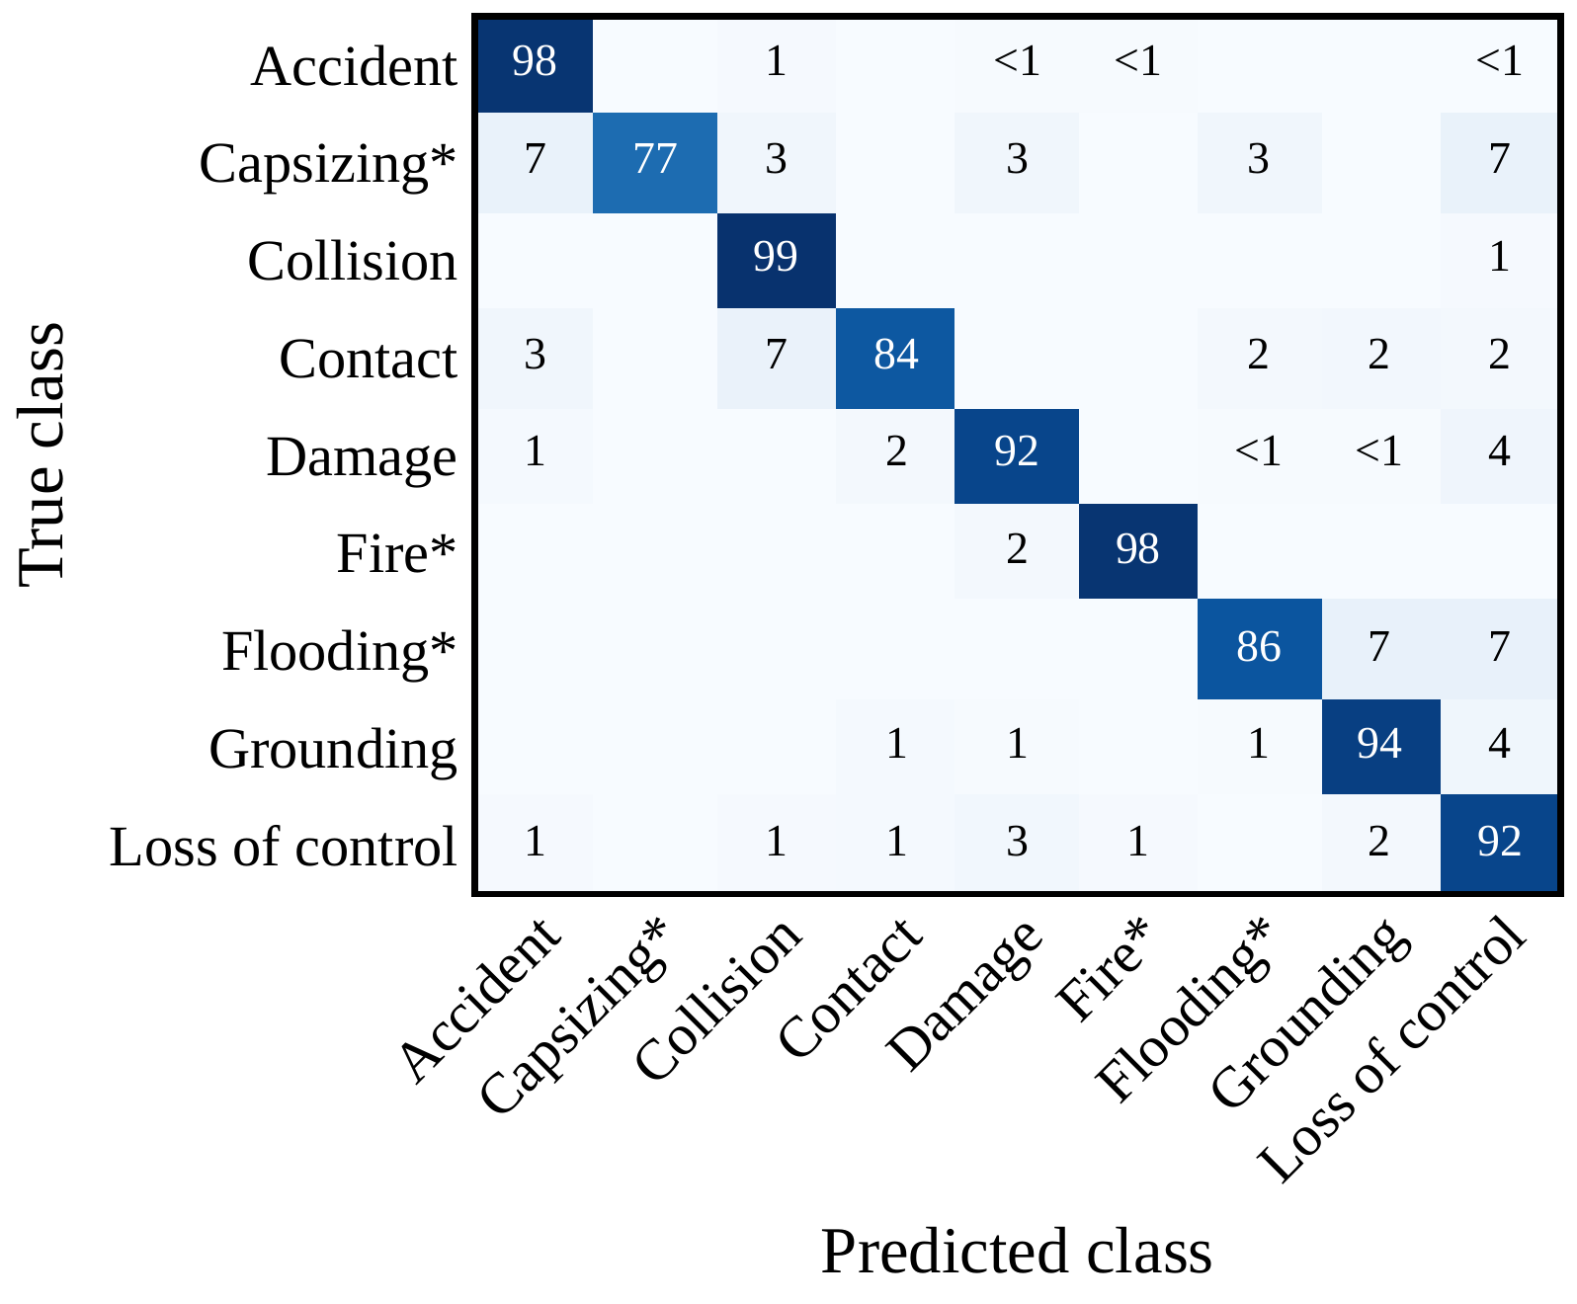
Fig. 2. Confusion matrix of the proposed framework, Att + wce + LLM augmentation, on the test set (two seeds summed), in percent of each true class.
Table V
Top five attention words per class, summed over correctly classified test reports (proposed framework, seed 1), without generic words such as vessel or crew. FRC: Fast Rescue Craft.
Class | Top attention words
Accident | passenger, fell, ship, cruise, sustained
Capsizing | capsized, boat, FRC, rescue, water
Collision | pilot, manoeuvring, collided, tanker, moored
Contact | contact, quayside, manoeuvring, cargo, lock
Damage | SOLAS, ladder, pilot, regulations, conform
Fire | engine, extinguish, caught, extinguished, smoke
Flooding | water, ingress, taking, started, motor
Grounding | grounded, aground, ran, water, rescue
Loss of Control | failure, engine, fishing, towed, fouled
The words with the highest attention (Table V) are mostly the expected indicators, e.g., capsized, ingress or aground. For Damage / Loss of Equipment, however, the top words SOLAS, ladder, pilot, regulations and conform point to a recurring subgroup of reports on pilot ladders that do not conform to the International Convention for the Safety of Life at Sea (SOLAS), hidden within a broad class. Attention shows where the model looked, not why it decided [20], but it helps to explore reports. The cause–consequence confusions, the shared attention words of related classes (manoeuvring among the top words of both Collision and Contact), and a linear baseline within 0.03 macro-F1 of the proposed framework suggest that the ceiling of about 0.91 comes from the single-label annotation rather than from model capacity.

V. Conclusions
This study proposed a framework for classifying marine incident reports. On 5,762 public MAIB reports, our proposed framework, which combines a BERT encoder, a BiLSTM and attention pooling with an imbalance-handling module of weighted cross-entropy and filtered LLM augmentation, reached a macro-F1 of 0.915 and an accuracy of 93.5%: significantly above a TF-IDF + SVM baseline (0.885, 91.4%) and above the BERT + BiLSTM architecture of [1] under the same settings (0.901, 92.8%), although the differences between BERT-based variants are not significant and most of the gain came from the weighted loss. The residual errors lie mainly between cause and consequence classes, and attention helps safety analysts find recurring subgroups such as noncompliant pilot ladders. Future work should add seeds and data splits, tune the training budget, evaluate domain-adapted encoders [2], and explore multi-label annotation that separates causes from consequences. Code and results are publicly available at https://github.com/CISLAB-SUT/MarineIncidentClassification.

References
[1] Z. Zhao, X. Liu, L. Feng, M. Grifoll, and H. Feng, “Causation analysis of marine traffic accidents using deep learning approaches: A case study from China’s coasts,” Systems, vol. 13, no. 4, p. 284, 2025.
[2] H. Black, R. Kurt, and O. Turan, “A domain-adapted NLP pipeline for human factors classification of maritime accidents,” Ocean Engineering, vol. 357, p. 125625, 2026.
[3] I. Munaev, “MAIB incident type dataset: Labeled marine accident reports for text classification,” Hugging Face dataset https://huggingface.co/datasets/baker-street/maib-incident-reports-5K, 2025.
[4] Y. Zhang, B. Kang, B. Hooi, S. Yan, and J. Feng, “Deep long-tailed learning: A survey,” IEEE Transactions on Pattern Analysis and Machine Intelligence, vol. 45, no. 9, pp. 10795–10816, 2023.
[5] X. Qiu, T. Sun, Y. Xu, Y. Shao, N. Dai, and X. Huang, “Pre-trained models for natural language processing: A survey,” Science China Technological Sciences, vol. 63, no. 10, pp. 1872–1897, 2020.
[6] H. Yu, X. Xu, Z. Guo, T. Wei, and L. Xu, “Semantic modeling of ship collision reports: Ontology design, knowledge extraction, and severity classification,” Journal of Marine Science and Engineering, vol. 14, p. 448, 2026.
[7] S. Wang, Y. Hou, P. Qiu, K. Wang, and B. Wang, “Ship fire and explosion accident evolution modeling based on ontology-enhanced text mining and dynamic Bayesian network,” Applied Sciences, vol. 16, p. 4984, 2026.
[8] W. Nguyen et al., “Llamarine: Open-source maritime industry-specific large language model,” arXiv:2503.00203, 2025.
[9] H. Park, J. Jung, M. Seo, H. Choi, D. Cho, S. Park, and D.-G. Choi, “AIS-LLM: A unified framework for maritime trajectory prediction, anomaly detection, and collision risk assessment with explainable forecasting,” arXiv:2508.07668, 2025.
[10] T.-Y. Lin, P. Goyal, R. Girshick, K. He, and P. Dollár, “Focal loss for dense object detection,” IEEE Transactions on Pattern Analysis and Machine Intelligence, vol. 42, no. 2, pp. 318–327, 2020.
[11] N. V. Chawla, K. W. Bowyer, L. O. Hall, and W. P. Kegelmeyer, “SMOTE: Synthetic minority over-sampling technique,” Journal of Artificial Intelligence Research, vol. 16, pp. 321–357, 2002.
[12] M. Bayer, M.-A. Kaufhold, and C. Reuter, “A survey on data augmentation for text classification,” ACM Computing Surveys, vol. 55, no. 7, p. 146, 2022.
[13] S. Hochreiter and J. Schmidhuber, “Long short-term memory,” Neural Computation, vol. 9, no. 8, pp. 1735–1780, 1997.
[14] M. Schuster and K. K. Paliwal, “Bidirectional recurrent neural networks,” IEEE Transactions on Signal Processing, vol. 45, no. 11, pp. 2673–2681, 1997.
[15] Z. Niu, G. Zhong, and H. Yu, “A review on the attention mechanism of deep learning,” Neurocomputing, vol. 452, pp. 48–62, 2021.
[16] Qwen Team, “Qwen2.5 technical report,” arXiv:2412.15115, 2024.
[17] C. Cortes and V. Vapnik, “Support-vector networks,” Machine Learning, vol. 20, no. 3, pp. 273–297, 1995.
[18] G. Salton and C. Buckley, “Term-weighting approaches in automatic text retrieval,” Information Processing & Management, vol. 24, no. 5, pp. 513–523, 1988.
[19] T. G. Dietterich, “Approximate statistical tests for comparing supervised classification learning algorithms,” Neural Computation, vol. 10, no. 7, pp. 1895–1923, 1998.
[20] J. El Zini and M. Awad, “On the explainability of natural language processing deep models,” ACM Computing Surveys, vol. 55, no. 5, p. 103, 2022.

